

Owen Hillary, Sam Ries, Owen Westerkamp

Project Objective:

This project aims to recreate the popular board game *Catan* (also known as *The Settlers of Catan*) as a digital, multiplayer game using Python. The game will replicate the core mechanics of the original board game, including resource management, tile placement, trading, and building settlements, cities, and roads. The project will focus on creating a user-friendly interface, implementing the game rules, and enabling multiplayer functionality.

1st Functionality:

The first part of our project that we worked on was getting a visualization of the board created. After making our board we could continue to build off of that and implement more features. Our first start to the game board looked like this.

After a couple of weeks, we started adding values to each Hexagon and coloring each one individually to the resource that it applied to there are 5 different resources in Catan Wheat, ore, sheep, brick, and lumber. There is another colored tile that the Robbers start in so we had to make sure to set the robber to always start in the desert tile. After updating all of our changes our board looked like this.

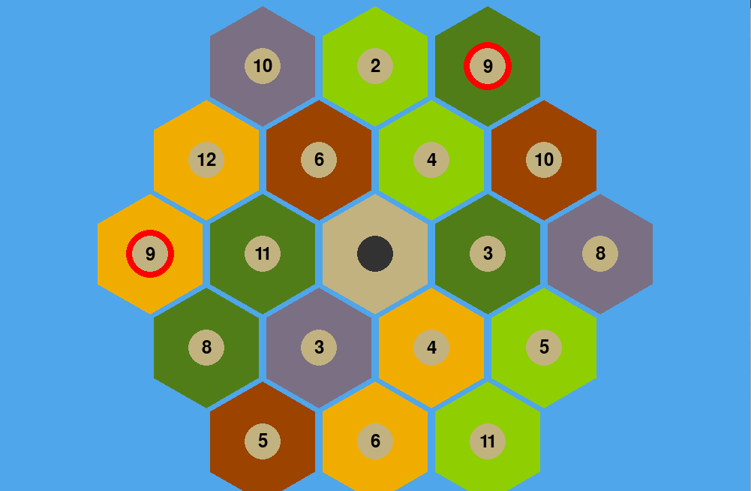

2nd Functionality:

The next thing we wanted to implement in our project was some background code and implementing dice-rolling and randomizing the board. Dice rolling is an important part of Catan that can affect what your turn looks like and how many resources you gain. Board randomization is an option players will have if they want to play on a randomly generated board or the beginner board. After implementing the changes, the board looked like this.

That was an example of the beginner board here is a showing of the dice being rolled and the randomization function.

